 | 20xx C420 [Insert Name of Championship] CHAMPIONSHIP    [Insert Dates of Championship]  Organizing Authority (OA): The [Insert Name] Yacht Club  in conjunction with the Club 420 Association, Inc.  NOTICE OF RACE

Things in red, there are decisions or changes needed based on the OA’s venue, etc. Have your PRO review. Change the color back to red or delete the red. Things with brackets [ ] indicates insertion of something normally needed and you can delete the brackets as well as this paragraph. Any changes you want to make is fine, and it will be reviewed and agreed upon by the OA and the Executive Director together. Our goal is to have this a smooth and stress free process!

- RULES
  - The regatta will be governed by the rules as defined by the Racing Rules of Sailing, the prescriptions of the United States Sailing Association (US Sailing) and the rules and By-Laws of the Club 420 Association.
  - RRS Appendix P will apply (or not apply) .

- ELIGIBILITY AND ENTRY
  - The regatta is open to boats meeting the requirements of the Club 420 class rules.
  - All competitors (both skipper and crew) must be current members of the Club 420 Association.
  - Individuals who will be twenty-two years or older in 20xx [ Insert current year) are not eligible to compete in this regatta.
  - Eligible boats may only enter by completing the online entry form and paying the entry fee before [Insert date] located at [URL of registration site or if not available at the time of publication, delete this]
  - All competitors must sign a “Release of Liability” [Insert the name of your Liability Form] located on the event website to participate in the regatta. [ Also consider using the online forms with electronic signatures ($1.00 per team]. Those competitors under the age of 18 must have their “Release of Liability” form signed by a parent or guardian.
  - No registration will be considered complete until all fees, required forms and signatures are received.

- FEES
  - The entry fee is [Insert contracted fee] if received on or before [Insert initial cutoff date, no earlier than two weeks prior].
  - Entry fees are non-refundable on or after [date] (optional bur recommended and no earlier than 1 week before w/o approval of the ED)
  - All refunds are subject to a 3% administrative fee.
  - A late fee of [Insert contracted fee] will be assessed for any entries received on or after 1700 on [Insert date]
  - Optional: Entry fees are non-refundable on or after [Insert date].
  - The entry fee includes [Insert specifics, i.e. breakfast, t-shirts, a dinner, BBQ, etc. etic, be brief]
- SCHEDULE
  - Competitors may arrive at [Insert your venue name] no earlier than [Insert date/time].
  - DATE TIME EVENT [Insert your schedule, sample below]
Wednesday, July 10 1200-1800 Check in
Thursday, July 11 0900 Coaches Briefing
0930 Competitors’ Meeting
1030 Harbor Start
1200 First Warning
After racing Social at [Insert location if anything to add]
Friday, July 12 0900 Coaches Briefing
1030 Harbor Start
1200 First Warning
After racing Social at [Insert location if anything to add]

Saturday, July 13 0900 Coaches Briefing
1030 Harbor Start
1200 First Warning
After racing Social at St. Francis Yacht Club
Sunday, July 14 0900 Coaches Briefing
1030 Harbor Start
1200 First Warning
1500 No warning after this time
After racing Social & Awards at [Insert location]
  - [Insert number, discuss with your PRO and the Class Executive Director and based on days of racing] races are scheduled.
  - The race committee may run up to four races per day provided that they do not get more than one race ahead of schedule.

- MEASUREMENT
  - Every skipper must complete and submit a signed Inspection Checklist prior to participation in the regatta at check-in. These forms will also be available at the check-in desk.
  - All boats are subject to safety inspection at any time during the regatta.

- SAILING INSTRUCTIONS
The sailing instructions will be available at check in and on the event website.

- VENUE
  - The intended racing area will be [Insert brief sentence on where the area is]
  - Attachment A shows the approximate location of the racing areas. [google area view of racing area recommended]
  - Attachment B shows the location of the Yacht Club or Regatta Harbor or? (optional at OA descretion)

- COURSES
A Trapezoid course will be run and will be published in the Sailing Instructions. (The class would like a trapezoid no matter the number of participants to ensure long reaches are part of the course. We understand that this may not be possible, if not discuss with the Executive Director).

- SCORING
  - The Low-Point Scoring System, RRS Appendix A, will be used.
  - One race must be completed to constitute a regatta. If he fleet is split into divisions, a race consists of all divisions completing a course with results that may be scored. This changes A2.
  - If more than 80 boats are registered, the fleet may be divided into divisions. (if you would like to change that, discuss with ED)
  - When four or less races are completed, a boat’s series score will be the total of her race scores.
  - When five or more races are completed, a boat’s series score will be the total of her race scores excluding her worst score. This changes RRS A2.
  - If the Fleet is divided into divisions, there will be a Qualifying Round and a Medal Round attempted. If fewer than five races have been completed before the start of competition on the last race day, then the regatta will remain in the Qualifying Round
format. If five or more races have been completed in the Qualifying Round before the start of the last day, there will be a Medal Round.
  - Scores from the Qualifying Round will carry forward into the Medal Round.

- SAFETY
  - Parents/guardians/or competitors 18 or over at the time of the start of the event are responsible for the safety of the competitors. It is the responsibility solely of the parent(s) of the competitors, or in the instance of the competitor who is 18 or over, the competitor, to decide if the competitor should sail in the weather and sea conditions that might arise during the event. Parents of competitors under 18 not personally attending any part of the event must ensure that another adult is authorized and designated to make these decisions for their child.
  - All competitors shall wear either a US Coast Guard approved PFD, or a PFD approved by the country of their citizenship or residence, properly secured at all times, from dock to dock except when temporarily adding or removing clothing. Wet suits, dry suits and inflatable PFD’s do not constitute adequate personal buoyancy. The ‘Y’ flag will not be flown. This changes RRS 40 and the preamble to Part 4.

- COACH AND SPECTATOR BOATS (SUPPORT BOATS)
  - All coach and spectator boats must register before racing begins and must always prominently fly a designated flag provided by the OA while in the water. [ Club 420 provides the Flags for the OA if needed]
  - Coach (and spectator if enough flags available) boats are required to register online [ this is an option in regatta toolbox] or with the Race Office and pay a $20 deposit for a support boat flag. Failure to return the flag at the end of the regatta will result in forfeiture of the deposit.
  - All coach and spectator boats are considered safety boats and at the direction of the OA or race committee, and will render aid if requested.

- PRIZES
  - Prizes will be awarded to first place through xxxxxx place. [ depends on size of the regatta, 10-15 percent coverage seems a good planning number, discuss with the Executive Director, if split fleets, please consider awards top 1 to 3 silver/bronze fleet finishers ]
  - The top placing Junior team in which both skipper and crew are under 17 throughout 20XX. [PUT IN CURRENT YEAR)

- DISCLAIMER OF LIABILITY
Sailing is an activity that has an inherent risk of damage and injury. Competitors in this regatta participate entirely at their own risk. See RRS 4, Decision to Race. The race organizers (OA, Ratings Authority, Race Committee, Protest Committee, host club, sponsors, the Club 420 Association or any other organization or official) will not be responsible for damage to any boat or other property or the injury to any competitor, including death, sustained as a result of participation in this race. By participating in this regatta, each competitor agrees to release the race organizers from any and all liability associated with such competitor’s participation in this event to the fullest extent permitted by law.

- OTHER REQUIREMENTS
  - If a competitor under the age of 18 is not accompanied by a parent or legal guardian during all activities of the regatta, then the parent or legal guardian shall name a “Designated Adult” of 18 years or older, through entry in the online registration process and shall be present at all times in their absence and who will supervise the minor competitor at all times to assure his/her safety. This Designated Adult will adult will accept full responsibility for all actions of the competitor during any activity related to the event. This includes on-shore activities before, during, and after the regatta.
  - For each competitor under 18, it is the competitor's parents, legal guardian or Designated Adult’s decision to enter the regatta and to start or continue any race. The adult(s) supervising the competitors are ultimately responsible for the risks.
  - A competitor age 18 or older retains all responsibilities for himself or herself.
  - No contestant shall use, either on or off the water, alcoholic beverages (beer, wine or distilled spirits) or use any controlled substance (marijuana, cocaine, etc.) the possession of which is unlawful. This prohibition is in effect during the entire event, from date and time of arrival through date and time of departure from the St. Francis Yacht Club. Penalties for a violation of the prohibition may range from a reprimand to dismissal from the regatta. A hearing may be held in accordance with the RRS.

- FURTHER INFORMATION
Venue
Venue Email or Regatta Manager Name / Number

Shipping address: [ of venue ]
Street Name
City, State Zip

ADDITIONAL INFORMATION BELOW

20xx C420 [Insert Name of Championship] CHAMPIONSHIP
[Insert Dates of Championship]
Organizing Authority (OA): The [Insert Name] Yacht Club
in conjunction with the Club 420 Association
ATTACHEMENT A - VENUE

SAMPLE
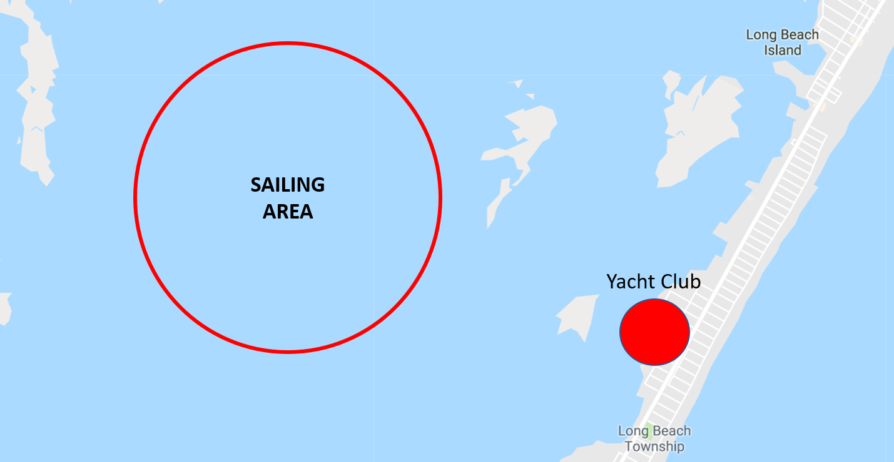

20xx C420 [Insert Name of Championship] CHAMPIONSHIP
[Insert Dates of Championship]
Organizing Authority (OA): The [Insert Name] Yacht Club
in conjunction with the Club 420 Association
ADDITIONAL INFORMATION (NOT PART OF THE NOR)

BOAT & TRAILER STORAGE

LODGING INFORMAITON

[ AND WHATEVER INFORMATION YOU WANT TO COMMUNICATE, i.e. SPONSORS, PARKING / TRAILER STORAGE / ETC. ]

CHARTERS [ contact charter providers and put their information here, samples below, VALIDATE THEY WANT TO CHARTER FOR THE EVENT ]

ZIM Sailing
Carson Gutowski
charters@zimsailing.com
401-237-6117
Charter Online
Sturgis Boats
Matt Wake
matt@sturgisboatworks.com
508-778-9187
Charter Online

